Advanced Games Engine Creation
Lights and materials
In this tutorial you will
- Practice specifying lights and materials in OpenGL

A red shiny ball
We will start by specifying and lighting a red shiny ball, as discussed in the lecture. Make a new copy of the OpenGL_SDL Base Project Framework. In the Render() method of GameScreenLevel1, comment out the triangle-drawing code and replace it with the lines:

glColor3f(1.0f, 0.0f, 0.0f);
glutSolidSphere(3.0, 20, 20);

You should see a flat red disc, because lighting has not been enabled yet.

Add two structure definitions to the file Commons.h:

struct lighting{
float ambient[4];
float diffuse[4];
float specular[4];
} ;

struct material {
float ambient[4];
float diffuse[4];
float specular[4];
float shininess;
} ;

At the top of the file GameScreenLevel1, include the Commons.h header file, so that we can use these structures.

Add the following to the end of the GameScreenLevel1 constructor, to enable OpenGl to use lighting – one light only for now:

// enable lighting
glEnable(GL_LIGHTING);
glEnable(GL_LIGHT0);

Replace the line
glColor3f(1.0f, 0.0f, 0.0f);
in the Render() method with the lines:
SetLight();
SetMaterial();

Add the following two methods to GameScreenLevel1, above the Render() method. You will also need to declare these two methods in the header file, GameScreenLevel1.h.
void GameScreenLevel1::SetLight(){
lighting light = {
{0.2f, 0.2f, 0.2f, 1.0f},
{0.7f, 0.7f, 0.7f, 1.0f},
{0.5f, 0.5f, 0.5f, 1.0f}
};
// position of the light in homogeneous coordinates (x, y, z, w)
// w should be 0 for directional lights, and 1 for spotlights
float light_pos[] = {1.0f, 1.0f, 1.0f, 0.0f};

glLightfv(GL_LIGHT0, GL_AMBIENT, light.ambient);
glLightfv(GL_LIGHT0, GL_DIFFUSE, light.diffuse);
glLightfv(GL_LIGHT0, GL_SPECULAR, light.specular);
glLightfv(GL_LIGHT0, GL_POSITION, light_pos);
}

void GameScreenLevel1::SetMaterial(){
material material = {
{0.80f, 0.05f, 0.05f, 1.0f},
{0.80f, 0.05f, 0.05f, 1.0f},
{1.0f, 1.0f, 1.0f, 1.0f},
100.0f
};

glMaterialfv(GL_FRONT, GL_AMBIENT, material.ambient);
glMaterialfv(GL_FRONT, GL_DIFFUSE, material.diffuse);
glMaterialfv(GL_FRONT, GL_SPECULAR, material.specular);
glMaterialf(GL_FRONT, GL_SHININESS, material.shininess);
}

Run your application - it should look like this:

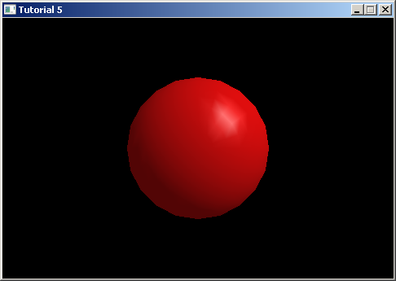

Different materials
Experiment with setting up different material properties in the SetMaterial() method. Try different colours for the ambient and diffuse components, and different values of shininess.
Look at http://www.opengl.org/archives/resources/code/samples/sig99/advanced99/notes/node153.html for inspiration – try simulating black rubber, or shiny brass.
Different light properties
Keeping the materials fixed, experiment with changing the light characteristics. Try different colours and intensities of the diffuse, ambient and specular light components.

Lighting the pyramid
Work through the slides “Lighting the pyramid” to add lights to the pyramid example we looked at in a previous tutorial.

Multiple lights
In either application, enable a second light, GL_LIGHT1, and set it in a different position to GL_LIGHT0. Move the light around the scene by declaring and initialising a variable to represent one of its coordinates (say the x-coordinate) and updating its value every frame.

Try creating a spotlight – see http://opengl.czweb.org/ch09/293-296.html for an example. To create a spotlight, you need to specify a cut-off angle and focus exponent, for example:

// Cut off angle is 60 degrees
glLightf(GL_LIGHT0,GL_SPOT_CUTOFF,60.0f);

// Beam is quite focussed (min is 0, max 128)
glLightf(GL_LIGHT0,GL_SPOT_EXPONENT,100.0f);

and specify the spotlight’s direction as well as position:

glLightfv(GL_LIGHT0,GL_POSITION,lightPos);
glLightfv(GL_LIGHT0,GL_SPOT_DIRECTION,spotDir);

